**GAME DESIGN DOCUMENT**

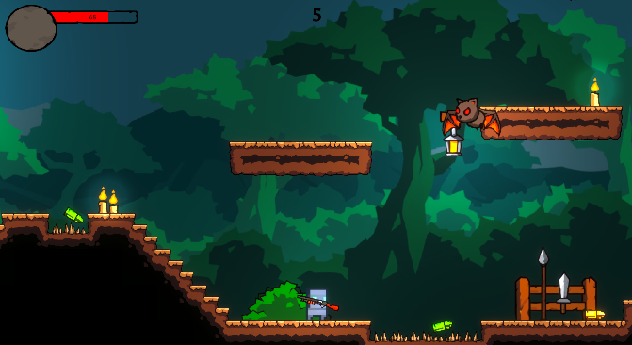

Lutom Pixel

created by Tamas Illes & Lukas Prinz

**Last Updated:**

1.9.2022

**Prepared By:**

Tamas Illes, Lukas Prinz

**TABLE OF CONTENTS**

Game Analysis 3

Mission Statement 3

Genre 3

Platforms 3

Target Audience 3

Storyline & Characters 4

Gameplay 5

Overview of Gameplay 5

Gameplay Guidelines 5

Game Objectives & Rewards 5

Gameplay Mechanics 5

Level Design 6

Schedule & Tasks 7

# Game Analysis

The game is based off a young Lutom, who will fight anyone standing in his way to rescue the younger Lutoms, spread and captured across the world. He can pick up weapons, bullets and move from one side to the other. There are different environments and enemies. Fight off other Lutoms in PVP and win by getting the most kills.

# Mission Statement

Lutom Pixel, an action platformer and multiplayer game for PC. He must overcome the enemies of different lands and rescue the younger Lutoms. Fight your own people if you must (PVP).

# Genre

Action, Platformer, 2D, and Multiplayer

# Platforms

PC

# Target Audience

People who love 2D and Pixel Art Games.  
People who love Shooter, Action and playing with friends.

# Storyline & Characters

Lutom, the main character, is travelling through the world to find and rescue the children of his people. On his journey he encounters a few of many hostile creatures. He will have to use everything he finds on his way (Weapons, Magical Bullets, etc.) to fight for survival. Not only will he encounter enemies from different worlds, but enemies of his own nation.

|  |  |  |  |
| --- | --- | --- | --- |
| Character | Description | Characteristics | Misc. Info |
| Player | A young and brave Lutom. He wants to rescue all the children from his nation. | He can jump a lot, jump higher and become faster by drinking potions. | He is cool. |
| Bat | The famous Dracula bats, which hunt Lutom’s people across the world. | They try to stick on you and damage you after seeing you. | Can fly. |
| Chicken | They want to get revenge for being treated badly. | They will run up to you and try to kill you. | Explodes. |

# Gameplay

## Overview of Gameplay

The player spawns in a closed off land, where he will have to quickly get a weapon, collect bullets and survive when the hostile creatures arrive.

## Gameplay Guidelines

Spawn, Jump, Collect Weapons and Bullets – Survive!

## Game Objectives & Rewards

It’s more of a competitive game between friends, and who can get the higher score in the game.

|  |  |  |
| --- | --- | --- |
| Rewards | Penalties | Difficulty Levels |
| The players kill and deaths are counted, each time, and every time. | Each time a player dies, his respawn time will be longer – and with every second the enemies grow stronger. | Difficulty will become harder after time |

## Gameplay Mechanics

|  |  |
| --- | --- |
| **Character Attributes** |  |
| **Character** | **Movement Abilities / Actions Available** |
| Lutom (Player) | Can jump, collect, drink potion, shoot, and double jump. |
| Bat | Will follow the player and attack him while trying to stick to him. |
| Chicken | Will run up to the player and explode – making the player go flying and get damage |
| **Game Modes** |  |
| PVE | Fight against hostile creatures with or without your friends. |
| PVP | Fight against your enemies, also known as “friends”. |
| **Scoring System** |  |
| **Points/Coins/Stars/Grades/Etc.** | **How it’s Awarded & Benefits** |
| Kills  Deaths  Won Matches | The players match, deaths and kills are being counted – which makes it competitive against other players. |

## Level Design

|  |  |
| --- | --- |
| **Levels** |  |
| Cave Map | The Cave, where younger Lutoms are being held hostage and enslaved. |
| Forest Map | The Deep Forest – bats and chickens everywhere but not so many young Lutoms to be seen or found. |
| Snow Map | The Cold Snowy Mountain. It has been told that it never stops snowing up there. |

# Schedule & Tasks

|  |  |  |  |  |
| --- | --- | --- | --- | --- |
| **Tasks to Complete & Schedule** | | | | |
| **Tasks** | **Task Lead** | **Start** | **End** | **% Complete** |
| **Development Phase** | | | | |
| Design |  |  |  |  |
| Storyline | Tamas Illes, Lukas Prinz | 02.09.2022 | 02.09.2022 | 99% |
| Level Mechanics | Tamas Illes, Lukas Prinz | 25.07.2022 | 02.09.2022 | 100% |
| Art |  |  |  |  |
| Levels | Tamas Illes, Lukas Prinz | 25.08.2022 | 02.09.2022 | 100% |
| Special FX | Tamas Illes, Lukas Prinz | 16.08.2022 | 20.08.2022 | 100% |
| UI | Tamas Illes, Lukas Prinz | 20.08.2022 | 30.08.2022 | 100% |
| Audio |  |  |  |  |
| Sound Design | Tamas Illes | 21.07.2022 | 23.07.2022 | 100% |
| Milestone: GamePlay Features & Music | Tamas Illes, Lukas Prinz | 24.07.2022 | 24.07.2022 | 100% |
| **Testing Phase** | | | | |
| Beta Testing | Tamas Illes, Lukas Prinz | 01.09.2022 | 01.09.2022 | 85% |
| **Deploying Phase** |  |  |  |  |
| "Go Live" Plans | Tamas Illes, Lukas Prinz | 02.09.2022 | 02.09.2022 | 100% |
| Milestone: Ready for Usage | Tamas Illes, Lukas Prinz | 02.09.2022 | 02.09.2022 | 100% |